T2 Payment Flow

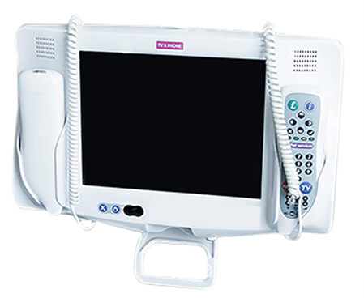

This is the Patient Journey for ordering an entertainment package through the new payment system. This is on T2 technology.

First the patient will need to select “Buy an entertainment package”

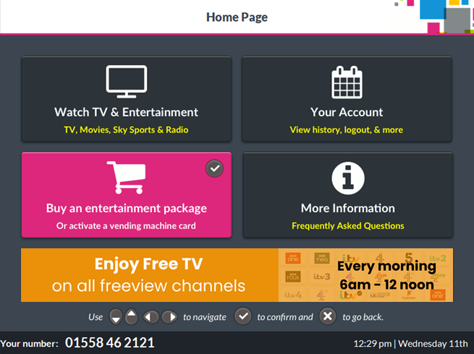

Then they can select a package from the options available.

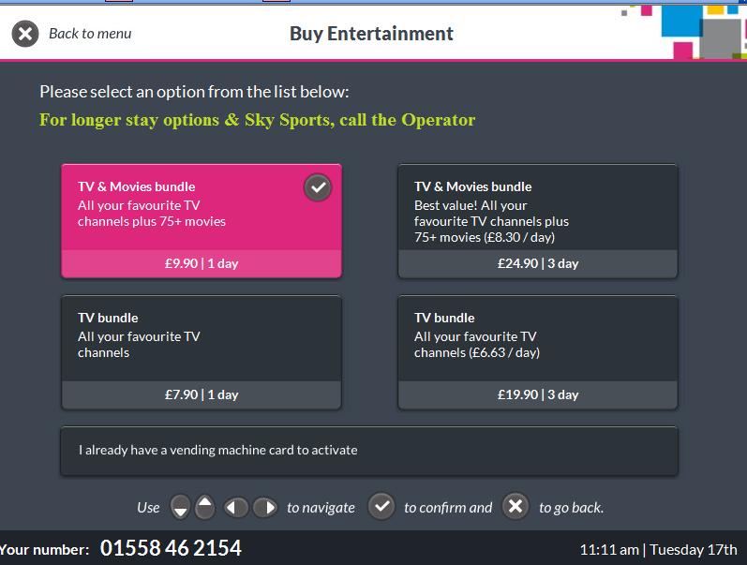

The patient can either confirm the bundle by selecting “Buy Now”, or select “Close” to be taken back to the previous screen. If the patient doesn’t have a smartphone, they can pick up the bedside unit phone and press the green operator button to talk to customer care.

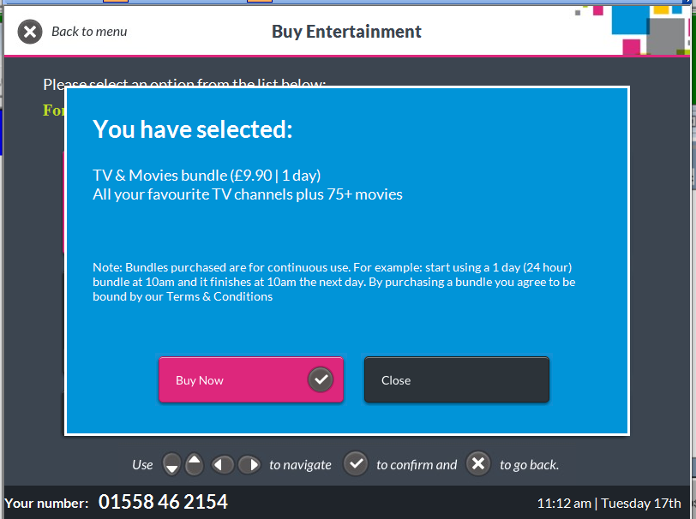

• The patient’s name will be displayed, and they must confirm if it’s them or not.
- If the patient’s name is correct, they will select “Yes That’s me” and will be taken to the next screen Confirm your account.
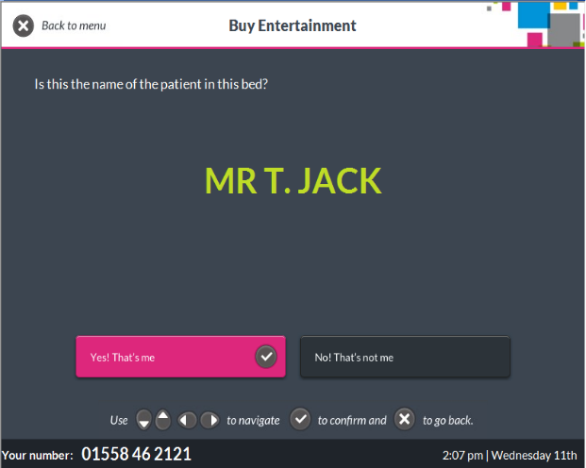

- If the patient’s name is not correct, they will need to register before purchasing an entertainment package​.
- The patient would select “No My details are wrong”​
- The patient will be presented with the registration screen and will need to fill out the required details.
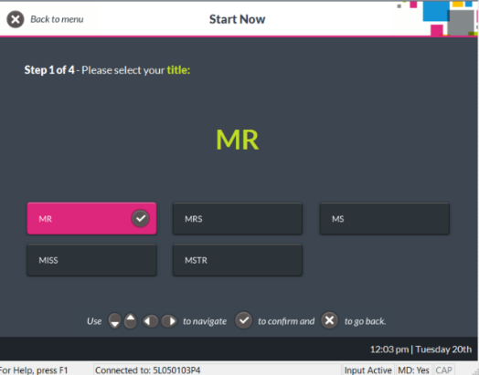
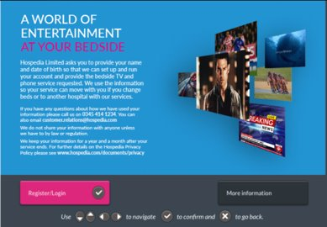

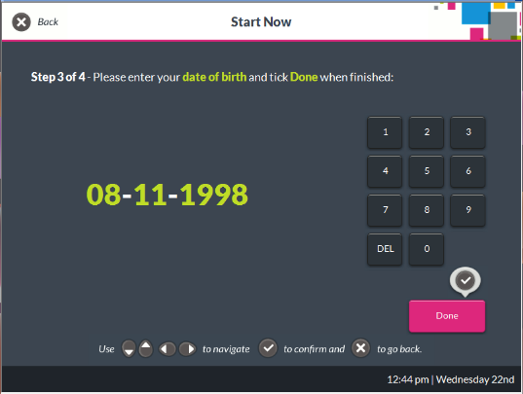
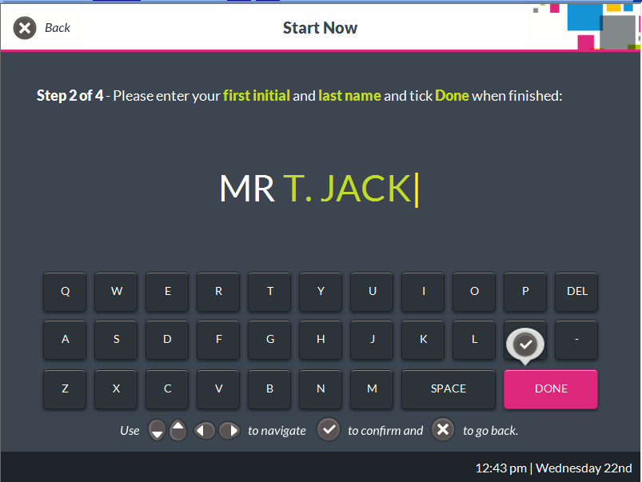

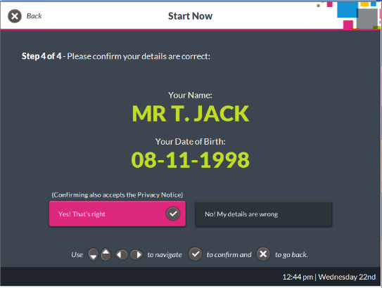

The patient will have three options to pay. Patients can choose to receive the payment link via text, email, or QR code.

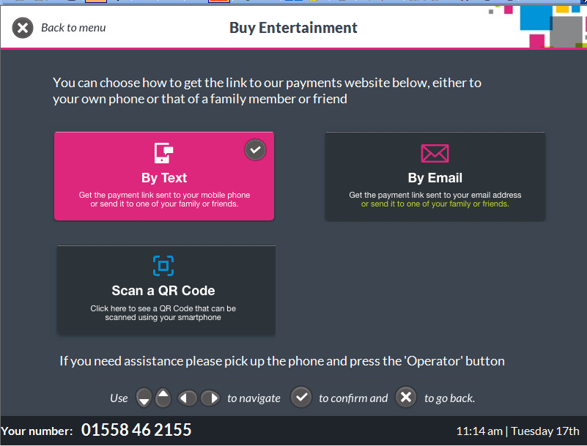

QR Code

- The patient will open their camera on a smart device (phone or tablet) and point it at the QR code. They will then select ‘Open link in browser’. Patient’s devices need to be connected to the internet for this to work.
- They will then be taken to the payment website.
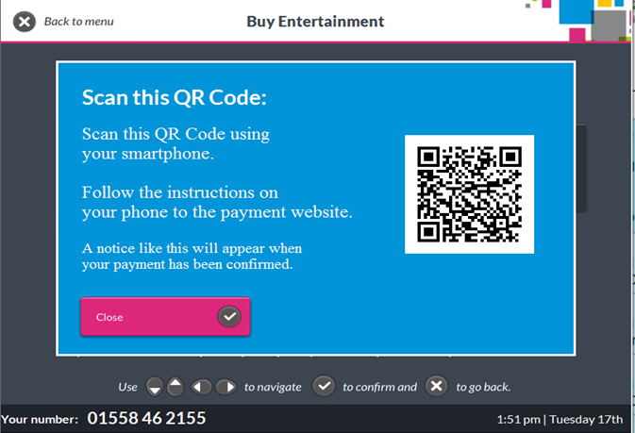

The patient will then see the following screen.
Please Note: If the patient is using an android device, there will be an option for Google Pay. If they’re using an Apple device, there will be an option for Apple Pay instead.

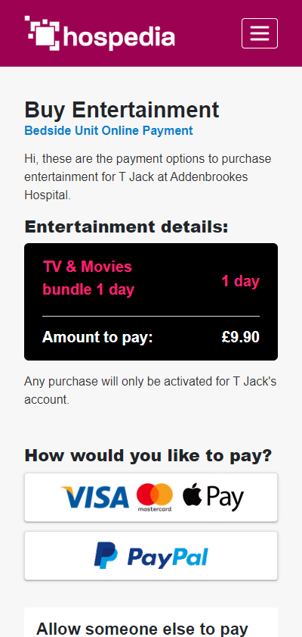
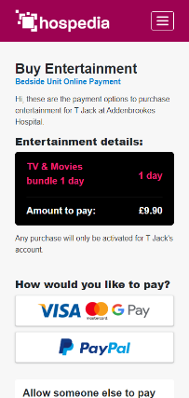

They can then choose to pay through visa/ debit card by inputting their details. Pay through Apple or Google Pay, else they can pay through PayPal. The user will be prompted to sign in and take the payment through the PayPal website.
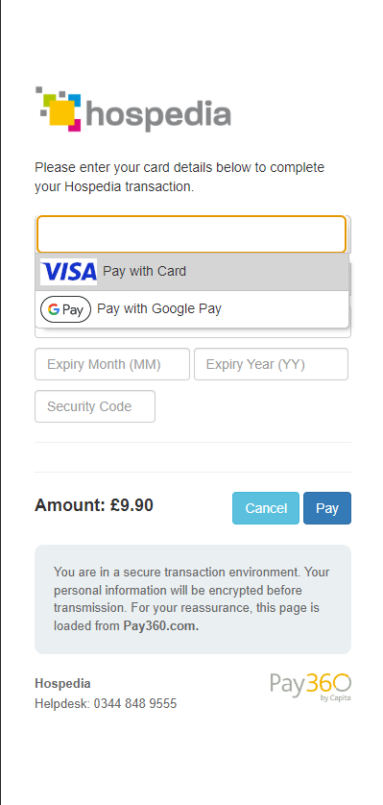
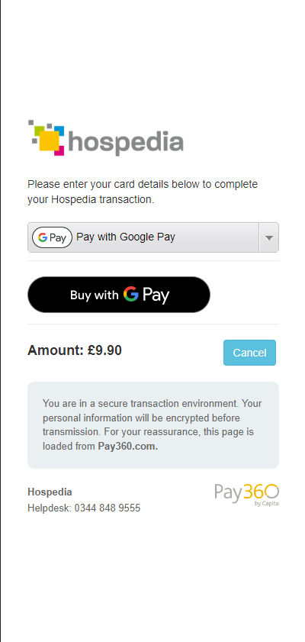
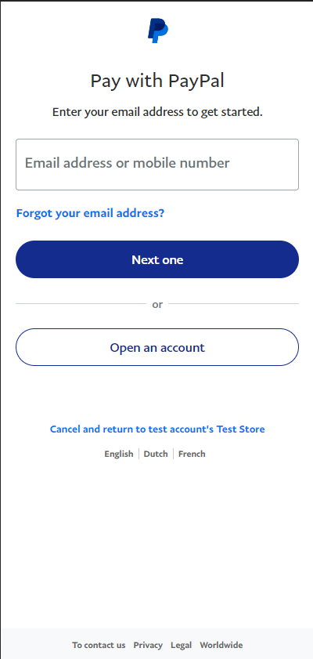

If the transaction was successful, “Payment complete” is shown.
If the transaction as failed, select “Go to payment options” and try again. The reason for a failed payment won’t be explained. E.g. Insufficient funds or invalid card.

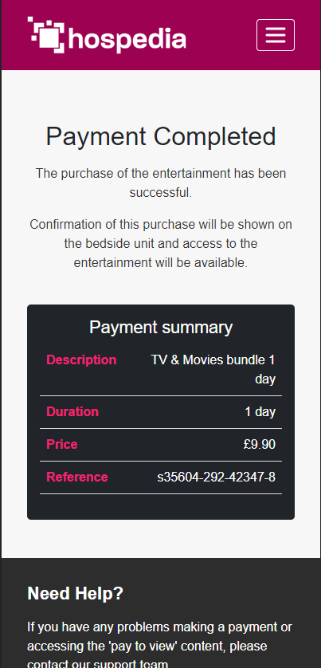
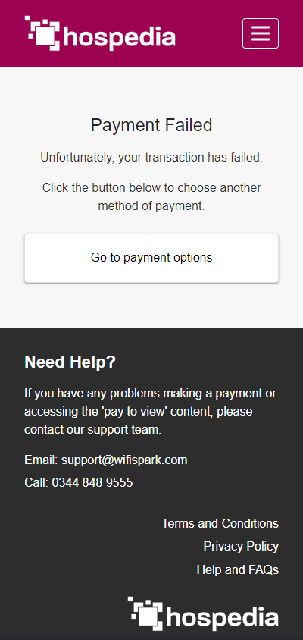

Back on the Hospedia Bedside Unit, there will be a screen that pops up saying “Payment Complete”. The patient can now access paid for services. There will be a timer under the entertainment options stating how much time they have left.

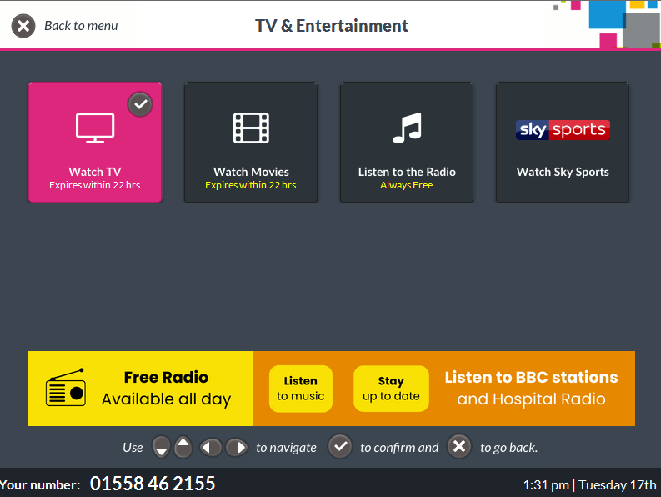

Text & Email

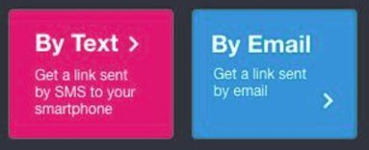

Once the patient has selected their chosen entertainment package, they are able to choose to send a text message or email to somebody who will make the payment. This can be sent to themselves, or someone who will pay on the patient's behalf​.
- Using the keypad, the patient can enter the UK Mobile phone number or the email address for the person who will be making the payment​.
- Once the Text or Email has been sent, a message will confirm that the Text/Email has been sent.
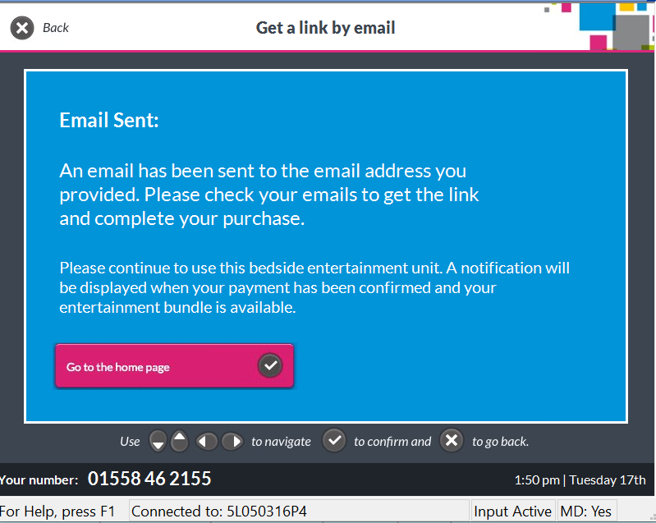
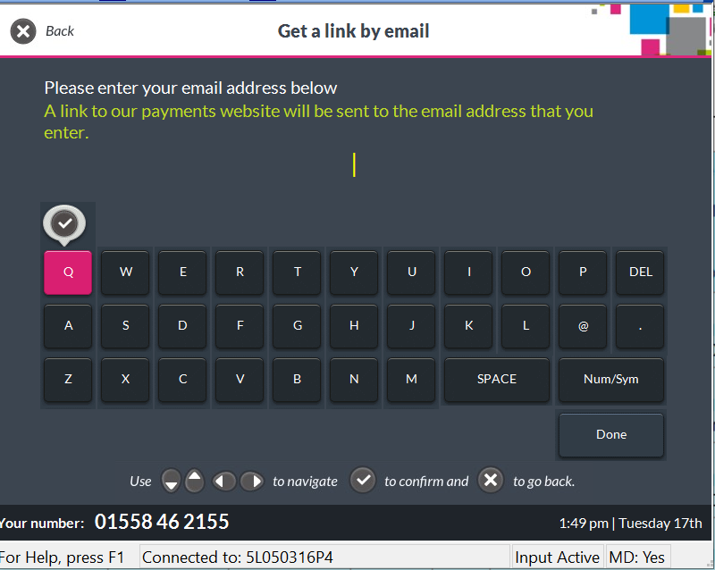
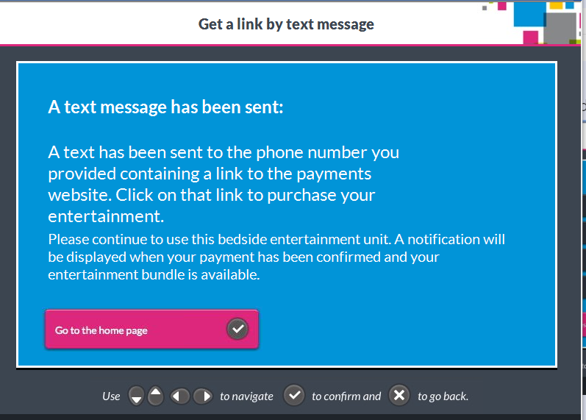
- The patient can continue to use the units free services and communication features while waiting for the payment to be made​
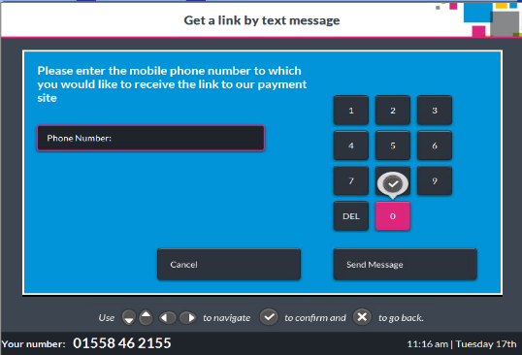

- The person paying for the entertainment package will now receive a text or email requesting they click on a link and complete the payment​.
- The payer will be taken to the payment page to complete the purchase on behalf of the patient. They can select the same options as provided earlier.
